Progress Report

1) Summary
- We finalized the Blood Elf theme and completed the initial full set of unit pieces.
- All pieces were imported into the Unity project with a consistent art pipeline.
- We specified movement rules for each unit class and aligned them with the 8×8 board.
- We remain aligned with the planning report’s target.

2) Progress
2.1 Foundations
Designed our first aesthetic direction: Blood Elf. Confirmed board size of 8×8; validated camera framing and tile readability. Established Unity project structure.
2.2 Asset Pipeline
Standardized import settings; created a template prefab.
2.3 Unit Roster
Drafted the unit class list and movement rules at the design level:
- Kael’thas Sunstrider (king-like)
- Phoenix Matriarch (queen-like)
- Runed Sunspire (rook-like)
- Hawkstrider Cavalier (knight-like)
- Spellweave Magister (bishop-like)
- Sunwell Acolyte (pawn-like)
2.4 Art and Prefabization
Completed models for all Blood Elf pieces and imported into Unity. Created prefabs per unit with mesh, basic collider, and material assignment.
2.5 Movement Rules
Finalized movement rule specs for each class.
2.6 Board and Readability
Maintained 8×8 board layout; iterated tile sizing to match unit scale.
Drafted tile highlight states (select and legal move).

3) Technical Notes
- Prefabs: Each unit has a base prefab with: MeshRenderer, MeshFilter, and a Collider.
- Scales & Pivots: Unified bounds so the board snap aligns to tile centers; future animation won’t shift world origin.
- Materials: Blood‑elf palette (gold/crimson) with metallic/roughness tuned for readability under top‑down light rig.

4) Deliverables Produced
- Art: Full Blood Elf unit set.
- Unity: Imported assets, prefabs for each piece and the initial scene with 8×8 board.
- Design Docs: Movement rule specifications per unit class.

- Some current result display:

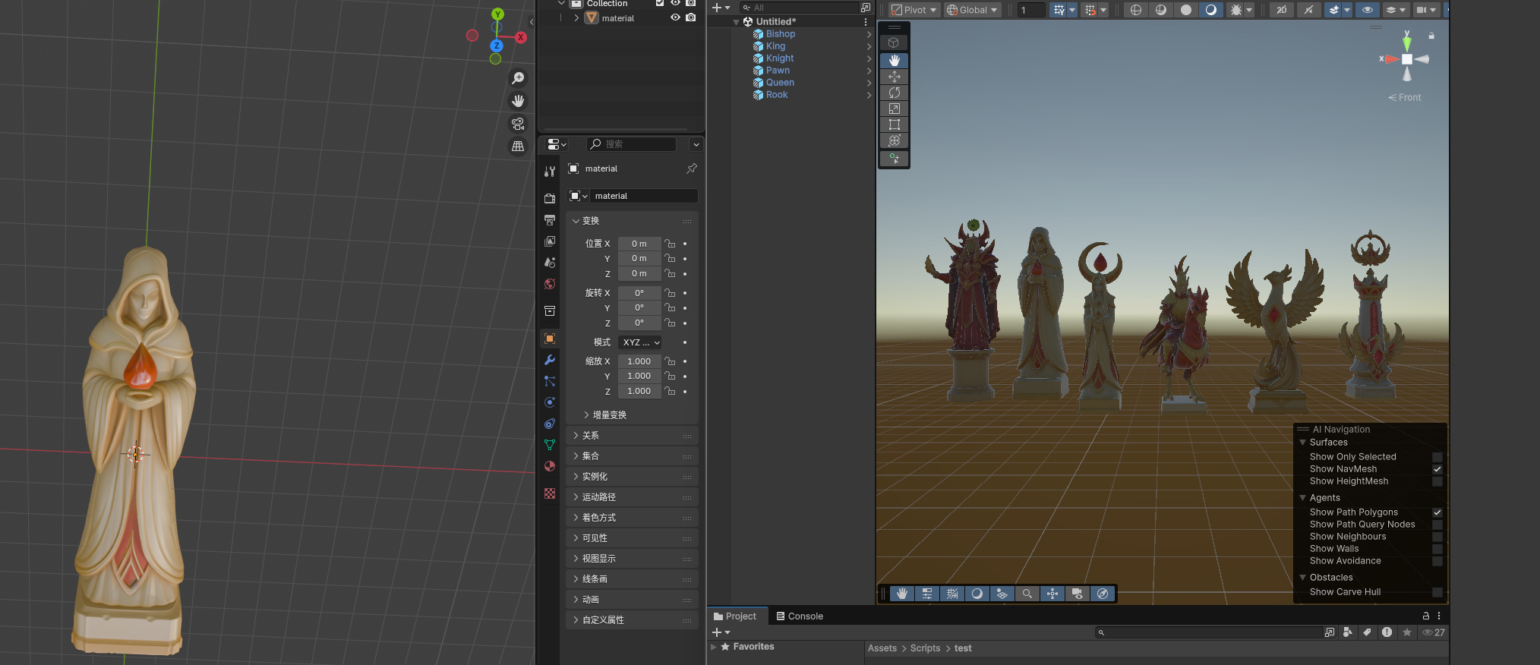
Our 3d model&prefab for blood elf
(2d 概念图由gpt5 & ps制作
3d 模型由腾讯混元3d&trellis&meshyai + blender制作）

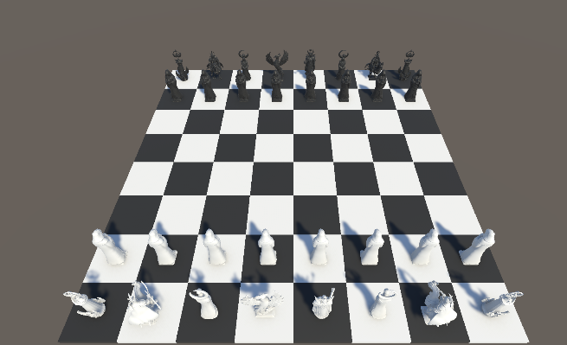
(Due to the needs for report, I change the material of elf for initializing, to have two sides. In our expected game, we will use different factions&different material to distinguished them.
Also , This camera is built for testing. We will modify our camera views afterwards

We have already implement a basic chess logic
With legal movement allowed
（some short example:
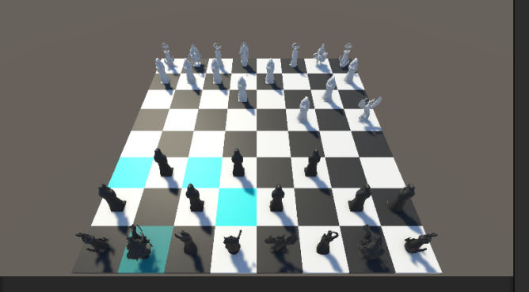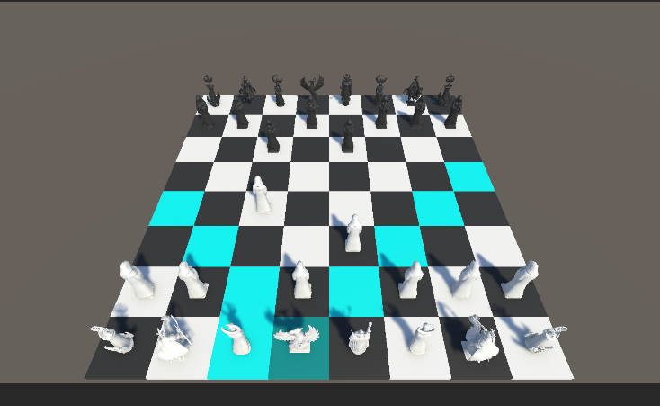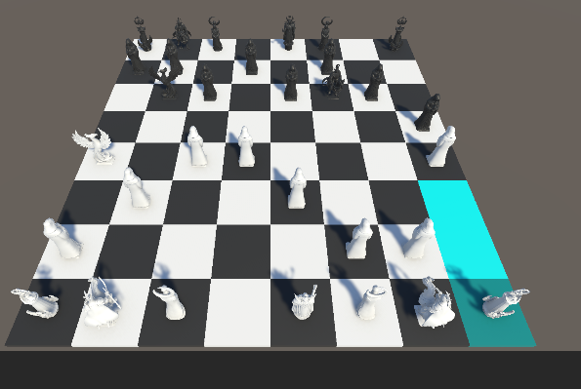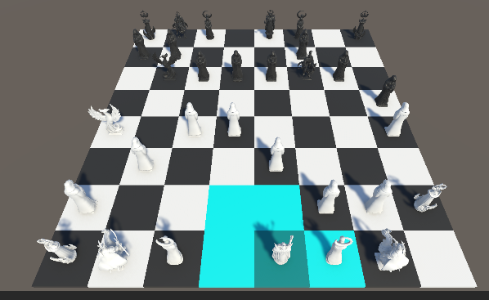

Our current project framework:
(Chess Set& Chess_pack are open-source unity asset. But abored. We have decided to design and build our own resource)
( Code Set UI is under design but still with some bugs.)
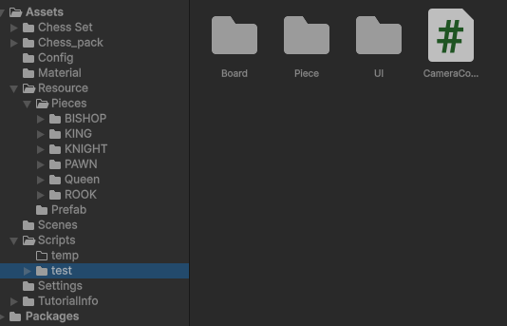

What we gonna do next:

We have already design some skills and propertity for our elf faction. Also, interface are prepared for each pieces. We will add some skills for elfs afterwards
(We also are designing some possible animation for using skills . But It may be hard, we may discard these ideas )

And the second faction is under design. We are modifying them.

